NON-MEMBER

Electronic Funds Transfer (EFT) Payment Program Authorization

The Electronic Funds Transfer (EFT) system retains banking information that is processed to pay the balance on this account via Automated Clearing House (ACH) bank transfer.
Please fill out the information below which authorizes the Irvington Club, located at 2131 NE Thompson Street, Portland, OR 97212, to pay off the accumulated balance on your Club charge account.
Account Holder Information/Authorization for Checking/Savings Account (ACH)

Name(s) Account Holder Phone

Account Holder Address City State Zip

Account Holder’s Bank Name Branch City State Zip

Account Type: □ Business Checking
Bank Routing Number (9 digits) Bank Account Number □ Personal Checking
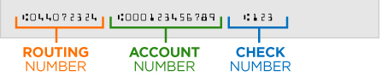
□ Savings
How to find your Routing and Account Numbers on a check

Recurring | Monthly | Variable
ACH Type | Frequency | Amount per Payment

I hereby authorize The Irvington Club to Debit the Bank Account referenced herein, via the Automated Clearing House (ACH) system, according to the parameters specified herein. This authority will remain in effect until the payment(s) are completed as specified herein. If a payment is returned for any reason I acknowledge that I am subject to a rejected item fee up to the maximum amount allowed by law.
Authorization
This authorization will remain in force until The Irvington Club receives written notice of termination.

Signature of Account Holder Print Name of Account Holder Date

